LAB 12: Creating a DFA from a given regular expression using JFLAP

INPUT RE

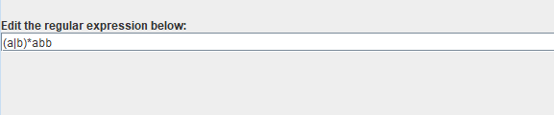

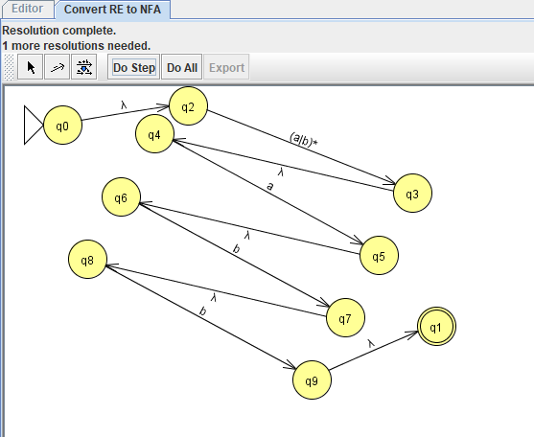

NFA TO DFA

